API ( application programming interface )

Some one wrote the code and he will give .class file end users will use and take the benefit

Java community wrote the code gave the String .class file to us , and we are using it . Entire java we are learning as API only .

javap java.lang.String shows method of the string

Note: if the class name and method name is same , then it is called constructor.

Some of the String class constructors are

String s = new String(); // creates empty String object

String s = new String (“ ”); // creates an object with String literals on heap and s.c.p

Eg: String s = new String (“hello”);

String s = new String(StringBuffer sb); // creates an equivalent string object for string buffer String buffer is converted to String .

Eg: String_Eg14

String s = new String (char[] c); // creates equivalent string object for character array

// Eg: String_Eg12

String s =new String (byte[] b); // creates equivalent string object for byte array

// Eg: String_Eg13

Note : since String is immutable , if a change is made in runtime space (object) for it will be created in the heap.

The above concept can be said as constructor overloading . same name but different parameters

Some Important methods of String :

1. public char charAt(int index)
2. public String concat(String str)
3. public boolean equals(Object o)
4. public boolean equalsIgnoreCase(String s)
5. public String subString(int begin)
6. public String substring(int begin , int end)
7. public intLength()
8. public String replace(char old, char new )
9. public String toLowerCase()

10.public String toUpperCase()

11. public String trim()

12. public int indexOf(char ch)

13. public int lastIndexOf(char ch)

14 . public String toString()

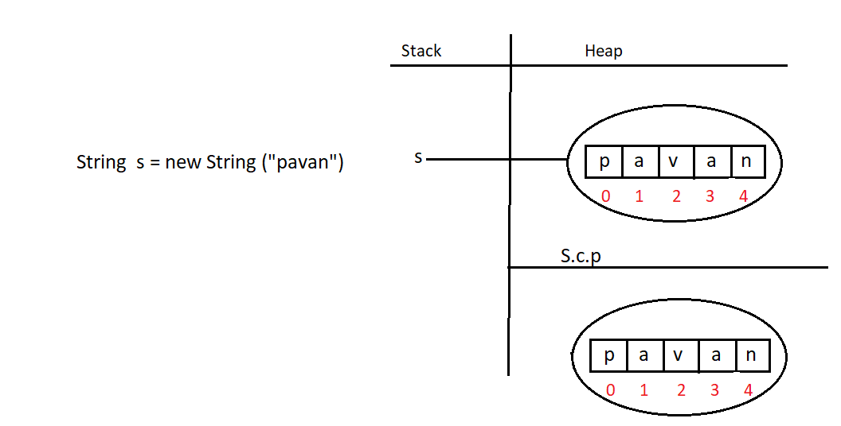

Even though the String is an object internally it is stored as array .

But if we try to access that array

System.out.println(s[3]) // compile time error

We cannot access them . it is only for memory level .

But we can access them as an array using charAt() method .

Eg: Strings_Method_Eg15

// go through the program.

Eg: String_Eg16

Here length() is a method of the String class , that can be accessed with String object . Even though String internally uses array we cannot use array property for it

Eg : String s = new String (“hello”);

s.length();

length is a property of Array class , array class is only for java (check previous notes on arrays )

class [I {

//property name

int length;

}

Eg: String_Eg17

concat() is a method of String class

String object by default is immutable (changes will reflect in new memory ) .

Eg: String_Eg18

// go through the program

Assignment :

username : [mohanpavankalyan52@gmail.com](mailto:mohanpavankalyan52@gmail.com) (not case sensitive )

password : ********** (case sensitive)

equalsIgnoreCase() method is used in usernames of many websites , example : gmail . Even though if we give case sensitive data it is ignored . only data is checked in username here .

But in password equalsIgnoreMethod is not used mostly .

Eg: String_Eg19

public String subString(int begin)

public String substring(int begin , int end)

They are example of method overloading.

Eg: String_Eg20

replace() method changes the specific character .

if there are multiple occurrences of the character all of them would be replaced.

Eg: String_Eg21

during runtime if object is created in the heap and if there is no reference , it will be on the heap until execution of that particular line is completed ( just like toUpperCase() in the print statement) . after that garbage collector will clean that .

Eg: String_Eg22

trim() method is removes the blank spaces at the starting and at the end , but not at the middle of the string.

Eg: String_Eg23

// go through the program

Eg: String_Eg24

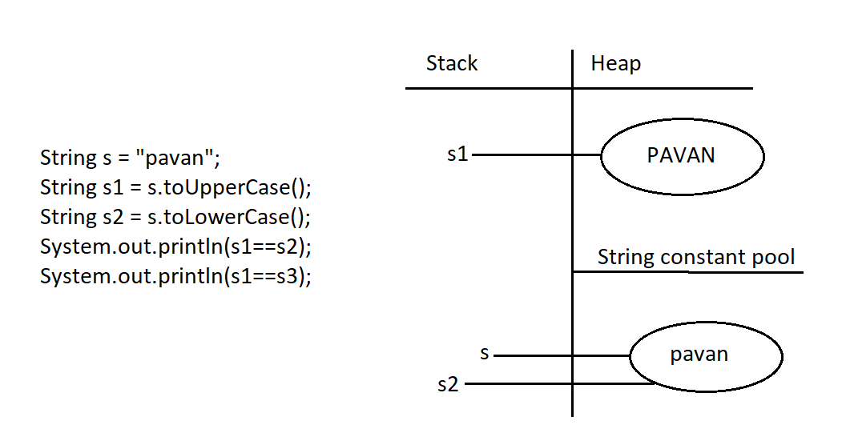

Even though runtime operation is involved , since there is already same data in s.c.p it is pointed to s2 .

Eg: String_Eg25

// whenever we try to print any reference , by default jvm will call toString() on the reference

Eg: String_Eg26

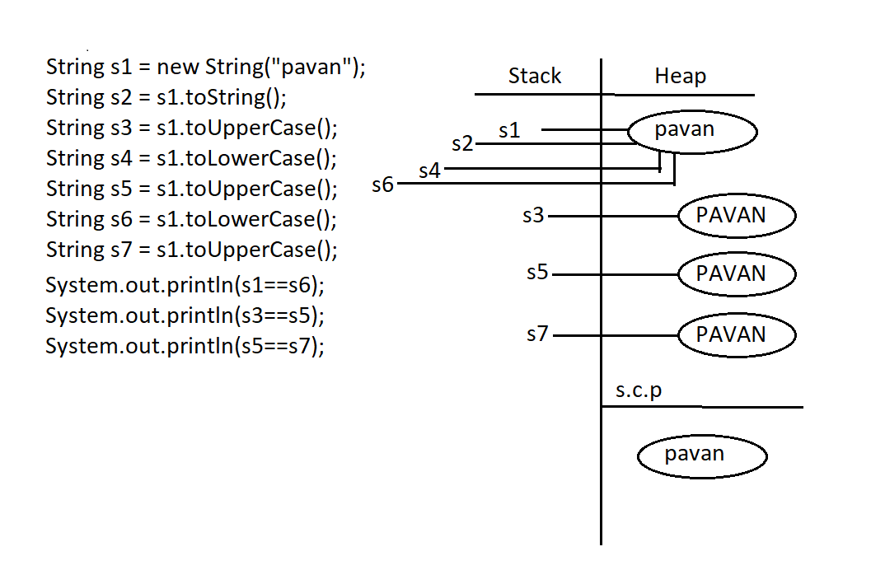

In heap area you can assign multiple references only to String containing new keyword. In this case we had assigned multiple references ( s2,s4,s6) to s1 since same data . s3 , s5, s7 even though runtime operations are performed and data is also same multiple references cannot be assigned to the same object as they are not created using new keyword .